Dis-Eur-Bulgaria-Harmanli-idol

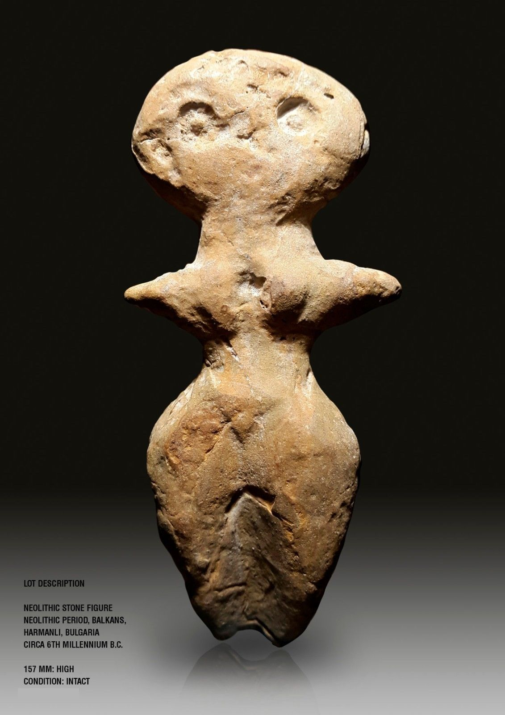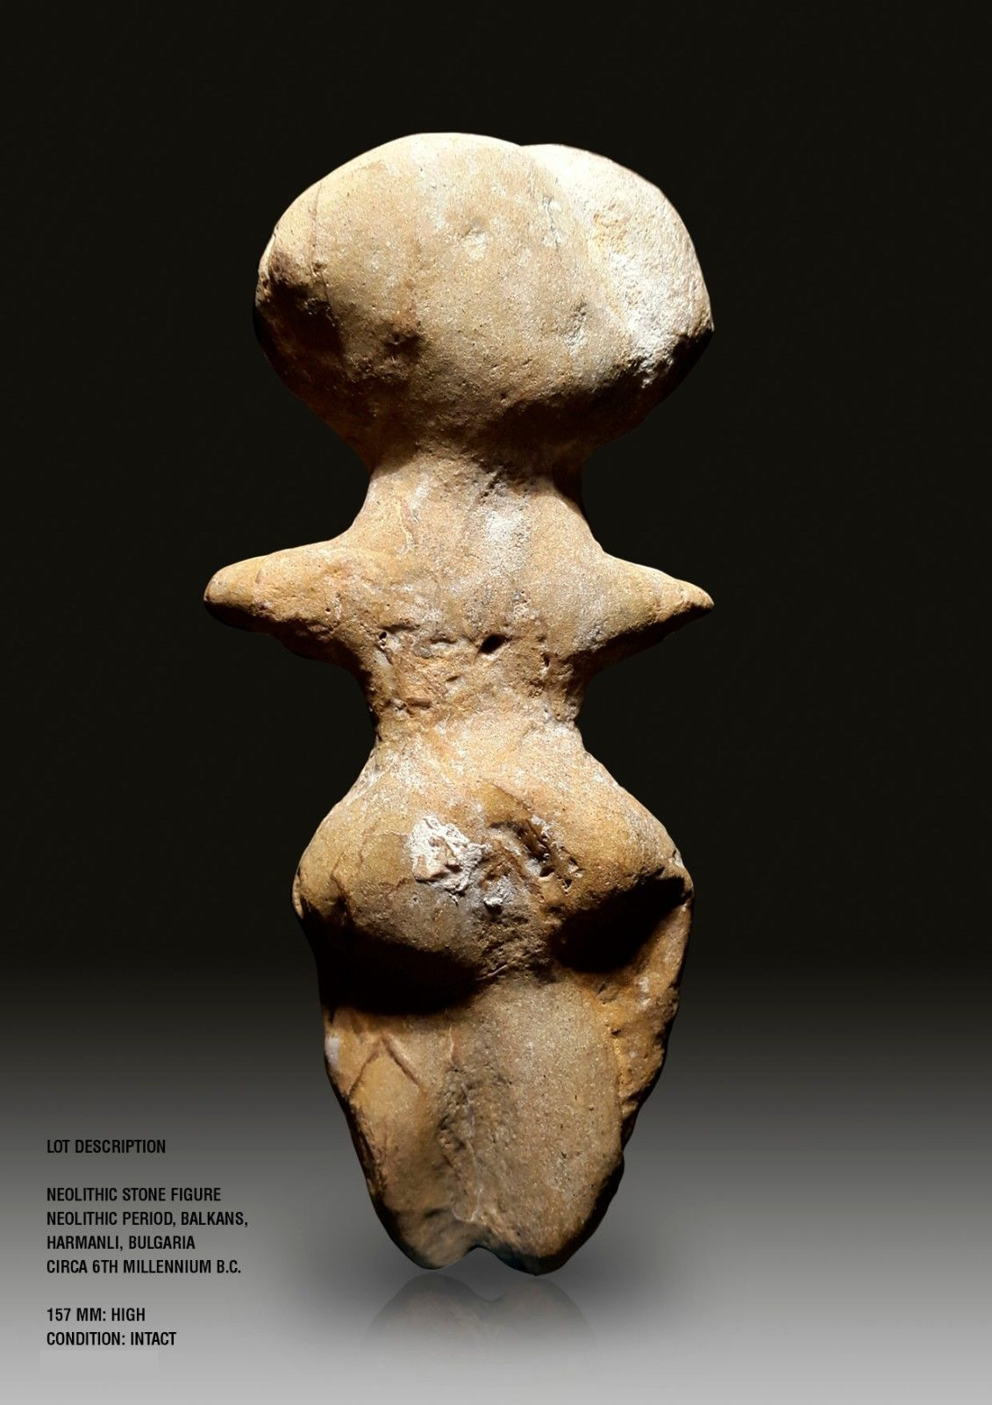 Formal Label: Neolithic stone figure, Harmanli, Bulgaria, ca 5th millennium BCE

Accession Number:

Date or Time Horizon: 5th millennium BCE

Geographical Area: Bulgaria

Cultural Affiliation: Neolithic

Medium: Stone with patina

Dimensions: H 157 mm

Weight:

Provenance: Italian Private Collection; then Martin Dimov Mladost 2, 239/3/3/88 1799 Sofia, Bulgaria.

Sold by [addixltd](http://myworld.ebay.com/addixltd) ( [130](http://feedback.ebay.com/ws/eBayISAPI.dll?ViewFeedback&userid=addixltd) )

Estimated delivery Thursday, Dec 1, 2016 - Tuesday, Dec 6, 2016

#### [Neolithic idol, Mother Goddess, Prehistoric idol](http://www.ebay.com/itm/172407370645)

|  |  |
| --- | --- |
| Item price | $247.26 |
| Quantity | 1 |
| Item number | 172407370645 |
| Shipping service | International Tracked Postage |

#### [Neolithic idol, Mother Goddess, Prehistoric idol](http://www.ebay.com/itm/172407370766)

|  |  |
| --- | --- |
| Item price | $247.26 |
| Quantity | 1 |
| Item number | 172407370766 |
| Shipping service | International Tracked Postage |